Unit 1: Introduction to Computers
OBJECTIVES
- Explain history, generation and importance of computers in 21st century
- Illustrate Von Neumann Architecture
- Elaborate basic hardware components of computer (Power supply, casing, motherboards, CPU, Chipset, real-time clock, BIOS, Parallel ports, serial parts and interfacing)

1.1 Basic introduction of computer
The word "Computer" is derived from the Latin word "Computare" which means 'to calculate'. Nowadays, computer has become an indispensable (essential) part of our life. Computer is used in various places like: home, school, college, offices etc. Computer can perform complex mathematical calculations accurately in a short period of time. The modern computer has lots of capabilities like creating documents, videos, games, music presentation, etc. It can use AI (Artificial Intelligence) for understanding natural language, taking self-decision capabilities, analyzing graphs and patterns, etc.

Example of AI task:
Self-driving cars, auto pilot, weather forecast, social media monitoring, smart assistants, disease mapping, etc.

A computer is an electronic device that accepts user input (data) and processes it under the influence of a set of instructions referred to as programs to produce the desired output generally referred to as information.

The 20th century saw the birth of one of the most important tools widely in use today called a computer. Today, computers are used for communication, management, research, drawing and design as well as entertainment. This 21st century is being referred to as the digital age. The modern world is called the age of science and technology. We cannot imagine life without science and technology. The modern world of advanced technology could not have been established without the development of computer technology.

1.2 Computer Organization (Block Diagram of Von Neumann Architecture)
Von Neumann architecture was first published by John von Neumann in 1945. His computer architecture design consists of a Control Unit, Arithmetic and Logic Unit (ALU), Memory Unit, Registers and Inputs/Outputs. Von Neumann architecture is based on the stored-program computer concept, where instruction data and program data are stored in the same memory. This design is still used in most computers produced today.
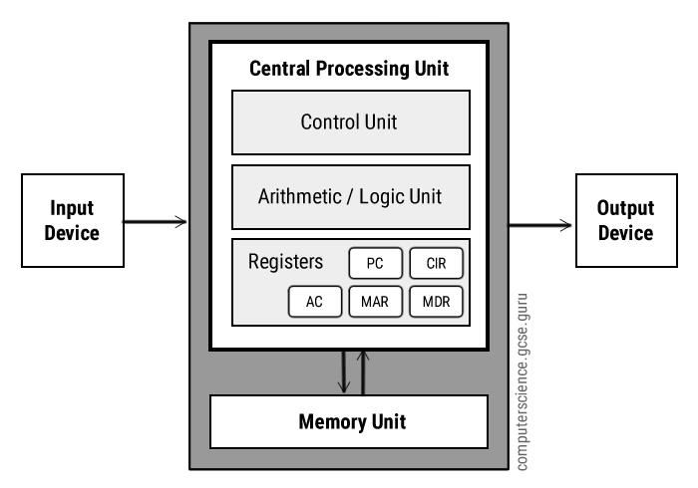
FIG: Concept of Von Neumann architecture
1. Input Unit:
This unit enters data into the computer. An input unit consists of input devices like keyboard, mouse, microphone, joystick, etc. These devices are used to enter data and instructions or commands into computer system. Input unit acts as a communication channel between user and computer. The input devices translate the information into a form understandable by the computer.
2. Central Processing Unit
A processing unit consists of processing devices like CPU (Central Processing Unit). CPU is the main processing unit of a computer system. It is also known as the brain of computer system. It receives data from input unit, processes it as instructed by the user and produces information as output. The speed of CPU is measured in hertz. Hertz is also called CPU clock rate or CPU clock speed.
Nowadays, CPU speed is measured in Gigahertz (GHz). 1 GHz = 1000 MHz (Megahertz) = 1,000,000 KHz (Kilo Hertz). = 1,000,000,000 Hz (Hertz).
The CPU consists of the three main parts.
i. CU (Control Unit),
ii. ALU (Arithmetic Logic Unit) and
iii. MU (Memory Unit- Register Array)
Control unit
The control unit controls the operation of the computer’s ALU, memory and input/output devices, telling them how to respond to the program instructions it has just read and interpreted from the mem

ory unit. The control unit also provides the timing and control signals required by other computer components. It coordinates the flow of data in or out of ALU, memory and various input or output devices.
Arithmetic Logic Unit
Arithmetic logic unit is a part of CPU that can perform arithmetic operation like addition, subtraction, multiplication and division. It also performs logical comparison like equal to, greater than, less than, etc. to compare between two numbers.
Register (Memory unit)
Registers are high speed storage areas in the CPU. All data must be stored in a register before it can be processed. It is located inside the microprocessor and has very limited storage. It is used to store very active data and instructions temporarily during processing.
MAR | Memory Address Register | Holds the memory location of data that needs to be accessed
MDR | Memory Data Register | Holds data that is being transferred to or from memory
AC | Accumulator | Where intermediate arithmetic and logic results are stored
PC | Program Counter | Contains the address of the next instruction to be executed
CIR | Current Instruction Register | Contains the current instruction during processing
3. Memory and storage unit
A storage unit consists of primary and secondary storages. The primary storage or main storage stores raw data and instruction. RAM (Random Access Memory) and ROM (Read Only Memory) are the examples of primary storage. The functions of the primary memory are below.
- It stores intermediate results of processing.
- It stores all the data and the instructions required for processing.
- It stores the final results of processing before these results are released to an output device.
The secondary storage stores processed or unprocessed data or information for future use. Hard disk, pen drive, CD, DVD, etc. are the examples of the storage unit
4. Output Unit
An output unit consists of output devices like monitor, printer, speaker, etc. These devices are used to display information after processing raw data from the processing unit.

1.3 Introduction of basic hardware components
Computer hardware is the physical components that a computer system requires to function. It encompasses everything with a circuit board that operates within a PC or laptop; including the motherboard, graphics card, CPU (Central Processing Unit), ventilation fans, webcam, power supply, and so on. Although the design of hardware differs between desktop PCs and laptops due to their differences in size, the same core components will be found in both. Without hardware, there would be no way of running the essential software that makes computers so useful. Examples of hardware are monitor, mouse, keyboard, computer data storage, hard disk drive (HDD), graphic cards, sound cards, memory, motherboard, and so on. The main hardware component of can be divided into 4 parts. They are:
1. Input unit. E.g. are keyboard, mouse, joystick etc.
2. Output unit e.g. are monitor, printer, speaker etc.
3. Processing unit e.g. microprocessor etc.
4. Memory unit e.g. RAM, ROM, hard disk, etc.

1.4 Power supply, casing, motherboards, CPU, Chipset, real-time clock, BIOS

1.4.1 Power supply
A Power Supply Unit (PSU) is an internal IT hardware component. Despite the name, Power Supply Units (PSU) does not supply systems with power - instead they convert it. Specifically, a power supply converts the alternating high voltage current (AC) into direct current (DC), and they also regulate the DC output voltage to the fine tolerances required for modern computing components.
Changing voltage is the prime use of power supplies. To prevent overload, power supplies step down the voltage — or, conversely, step it up — to match the requirements of the device. Too much power coming out of a power supply can severely damage a device, but if the power supply does not deliver enough voltage, the device will not operate as it should.
Most power supplies are switched-mode power supply (SMPS), which has both efficiency advantages and makes designing for multiple voltage inputs easier. This means that most PSUs can operate in different countries where the power input might change. In the UK, the voltage is 240V 50Hz, whereas in the USA the voltage is 120V 60Hz, and in Australia it is 230V 50Hz.

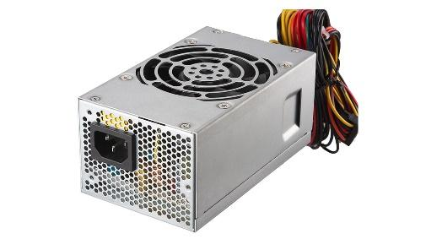
Fig: power supply

1.4.2 Casing
A computer case, also known as a computer chassis, tower, system unit, CPU (when referring to the case as a whole rather than the processor), or cabinet, is the enclosure that contains most of the components of a personal computer (usually excluding the display, keyboard, and mouse). Cases are usually constructed from steel or aluminum. Plastic is sometimes used, and other materials such as glass, wood etc. Some popular computer case manufacturers include Xoxide, NZXT, and Antec.
There are several reasons why we use computer cases. One is for protection from dust, animals, toys, liquids, etc. that can all damage the internal parts of a computer if the hard shell of a computer case doesn't enclose them and keep them away from the outside environment. Another good reason to use a computer case is to keep the area cool. Proper airflow over the computer components is one more benefit to using a computer case. Keeping noisy computer parts, like the fans, in a closed space within the computer case is one way to reduce the noise that they make.

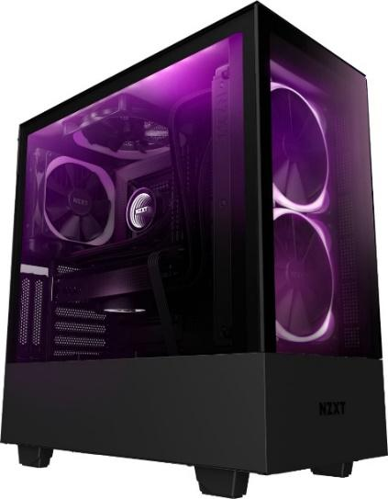
Fig: NZXT Casing

1.4.3 Motherboard
Motherboard is called PCB (Printed Circuit Board) or system board or main circuit board. All parts of computer system like microprocessor, slots, ports, CMOS battery, serial and parallel port etc. are mounted on motherboard. So, it is also called backbone of computer system. It also connects important chips like ROM chip, Network chip, sound card, etc. It connects almost all of the other parts together in a computer.
Function of motherboard
- There are different slot which joins modem, TV card, etc. in motherboard.
- Motherboard helps in data communication among different hardware.
- BIOS (Basic Input Output System) programs are stored in ROM and ROM is attached to motherboard to boot the system.

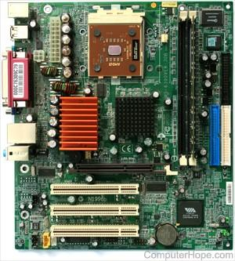

Fig: motherboard

1.4.4 CPU
The CPU is also called microprocessor, is the main IC chip on the computer’s motherboard. Computer cannot perform the task without a microprocessor. So, it is also called the brain of a computer. Microprocessor gets data and instruction from various hardware and processes it with the help of software to produce information as an output to the user. It can do arithmetic calculation and logical comparison between two numbers. Nowadays, a trillion of instructions can be processed within a second. Most motherboard will accept more than one type of microprocessor as far as model, manufacturer, and speed are concerned, but they generally accept only one socket type. The major microprocessor manufacturers include Intel, Motorola, IBM, Advanced Micro Devices (AMD) and Cyrix.
Working of Microprocessor

i. Fetch: The user can give data and instructions which is stored in RAM. Microprocessor receives data and instruction according to necessity and requirement which is known as fetch. So, fetch means get instruction from memory.
ii. Decode: The main function of microprocessor is to change fetched instruction into decoded instruction. The given instruction is separated for arithmetic or logical calculation. So decode means to decide what the instruction means.
iii. Execute: Microprocessor can perform the main task in this unit. For example, ALU is used for mathematical calculation. So, execute means to carry out the instruction into action.
iv. Write back:
Microprocessor processes the instructions and produces result which is transferred to memory for storage. This is called to write back. The complete cycle of four units as fetch, decode, execute and write back of microprocessor for processing the instruction is called the instruction cycle.

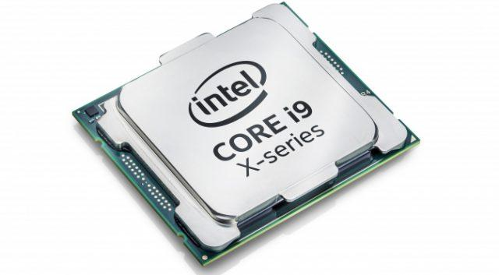
Fig: microprocessor

1.4.5 Chipset
An electronic chipset manages the flow of data between components on a motherboard. It’s the traffic controller between the CPU, GPU, RAM, storage, and peripherals. Experts have referred to it as the “glue” of the motherboard. The chipset is basically the electronics on the motherboard that communicate with all the connected components.
Today’s integrated chipsets live on the motherboard and allow components to communicate with each other through the motherboard from a centralized location. But in the past, there were smaller, individualized chips for each component.
As time went on, chip functionality consolidated into two main chipsets, the faster Northbridge that connects directly to the CPU and memory, and the slower Southbridge.
The Southbridge, which is not directly connected to the CPU, is also known as the input/output controller hub including input/output (I/O) devices and computer peripherals like expansion slots and hard disk drives. The Northbridge connects the Southbridge to the CPU and is commonly known as the memory controller hub. The Northbridge handles a computer's faster interaction requirements and controls communication between the CPU, RAM, ROM, the basic input/output system (BIOS), the accelerated graphics port (AGP) and the Southbridge chip. The Northbridge links I/O signals directly to the CPU.
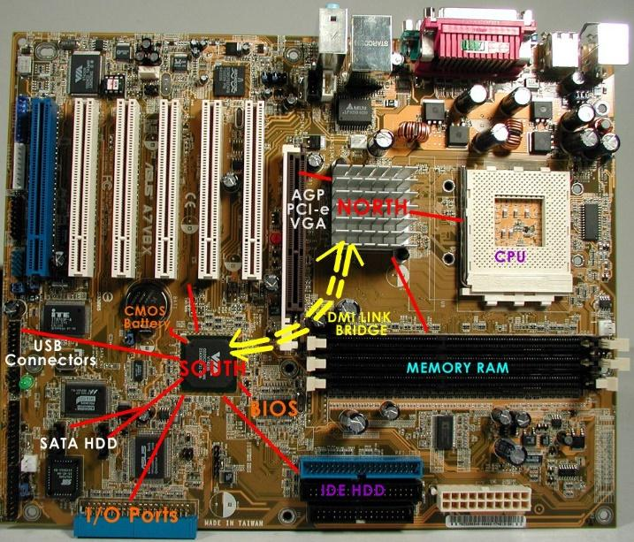
Fig: chipset

1.4.6 Real time clock (RTC)
A real-time clock (RTC) is a computer clock, usually in the form of an integrated circuit that is solely built for keeping time. RTC is powered by the CMOS battery. Naturally, it counts hours, minutes, seconds, months, days and even years. RTCs can be found running in personal computers, embedded systems and servers, and are present in any electronic device that may require accurate time keeping. Being able to still function even when the computer is powered down through a battery or independently from the system’s main power is fundamental.
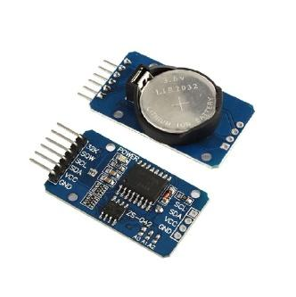
Fig: Real time clock

1.4.7 BIOS
BIOS or Basic Input/output System is responsible for booting up your system. It is programmed on an erasable programmable read-only memory (EPROM) chip, BIOS is used by the CPU to perform start-up procedures when the computer is turned on. Its two major procedures are determining what peripheral devices (keyboard, mouse, disk drives, printers, video cards, etc.) are available and loading the operating system (OS) into main memory. The BIOS system is also responsible for managing data flow between your computer’s operating system and any attached devices including a hard drive, keyboard, video adapter, printer, or mouse. Each time you power your PC on, BIOS runs through a process called Power-On Self-Test, or POST, that determines whether your attached devices are operating correctly and are in their proper place. Once all attachments are allocated and given the OK, your computer startup continues as usual and takes you to your load screen in a matter of seconds. If BIOS detects any problems, an error screen will appear or a series of beep codes will sound, effectively indicating to you that something has gone wrong.

1.5 Parallel ports, serial ports, interfacing (IDE, SATA, PATA, ATAPC)

1.5.1 Parallel ports
The parallel port is found on the back of the computer and is part of the motherboard. On PCs, the parallel port uses a 25-pin connector (type DB-25) and is used to connect printers, and other devices that need relatively high bandwidth. The data is transmitted over a parallel cable extending no more than the standard 6 feet. If the cable is too long, the integrity of the data can be lost. It is often called a centronics interface after the company that designed the original standard for parallel communication between a computer and printer. Parallel ports became popular because they were able to transmit data in parallel at a faster rate than was standard at the time. In the past, the parallel port was widely used for printers and occasionally for connecting other devices externally, but today parallel port is replaced by USB.
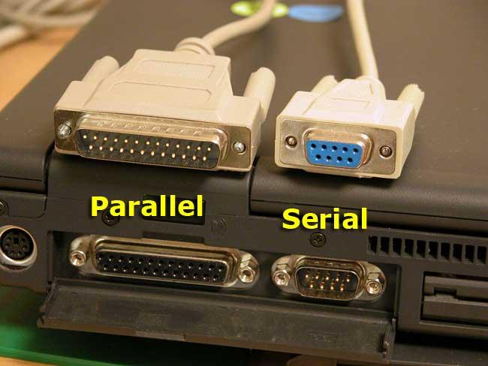
Figure: parallel and serial port

1.5.2 Serial ports
A serial port is an interface that allows a PC to transmit or receive data one bit at a time. They are 9-pin connectors that relay information, incoming or outgoing, one byte at a time. It is one of the oldest types of interfaces and at one time was commonly used to connect printers and external modems to a PC. Modern serial ports are used in scientific instruments, shop till systems such as cash registers and applications like industrial machinery systems. Compared to a parallel port, the data transfer rate of a serial port is slower. A parallel port could support rates up to 100 kilobytes per second, while serial ports only supported 115 kilobits per second (kbps). Later, enhanced technology pushed serial speeds to 460 kbps. Normally, a serial port is a male port, while a parallel port is a female port.
Difference between parallel port and serial port
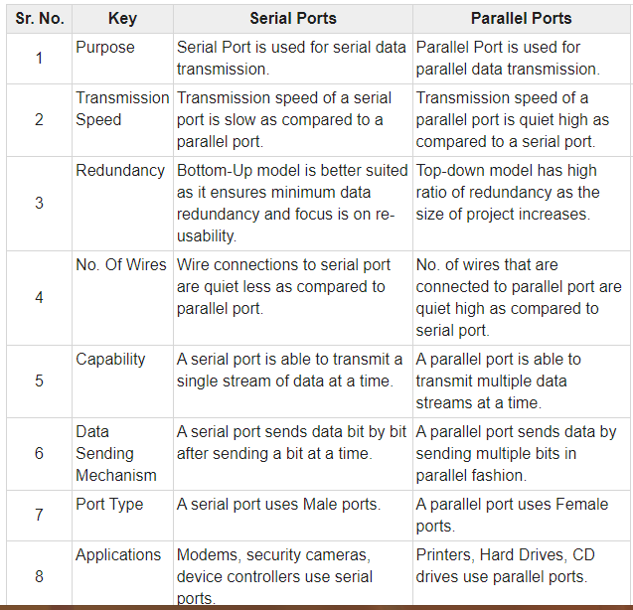

1.5.3 Interface
All peripheral devices are connected to the motherboard hcables. An interface cable is connected tence to the CPU by special cables called interface to the device on one end, and to the motherboard via ports on the other end. The difference between the power cables and the interface cables is that the power cable supplies power to a component while interface cables transmit data signals.

1.5.3.1 IDE
IDE Cables connect from the motherboard of a computer to the hard drive, cd drive and/or floppy drive. IDE stands for Integrated Drive Electronics. IDE is a standard interface that connects the computer motherboard to a storage device. The most common of these types of cables are the 34-pin floppy drive cable that connects from the motherboard to the floppy drive and the 40-pin ribbon cable that connects from the motherboard to the hard drive and/or the cd drive. The IDE cable is a type of ATA which has had speeds from 33, 66, 100 and 133 MB/s. A faster cable can go in a slower hard drive but a slower cable will decrease the speed of a fast hard drive. One IDE ribbon cable can connect a hard drive and a cd drive to the motherboard. It can also connect two hard drives to the motherboard. A single IDE ribbon cable has three connections. One connection connects to the motherboard and the other two connections are available for the two drives.
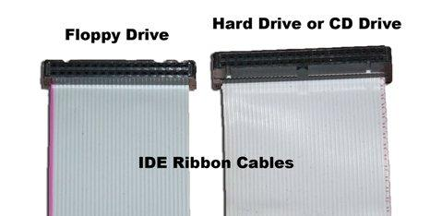

1.5.3.2 SATA
SATA which is the abbreviation of Serial Advanced Technology Attachment is an IDE (Integrated Drive Electronics) standard for storage devices like optic cables, HDDs, and SSDs connected to motherboards in computers. It is an advanced version of Parallel Advanced Technology Attachment or PATA. The SATA connectors and cables are capable of transmitting data much, much faster than PATA. With data transfer speeds from 1.5Gb/s to 12Gb/s. Compared to Parallel ATA, Serial ATA also has the benefit of cheaper cable costs and the ability to hot-swap devices. Hot-swap means that the devices can be replaced without turning off the entire system. With PATA devices, you have to shut off the computer before replacing the hard drive. SATA cables themselves are much smaller than the fat PATA ribbon cables. This means that they're easier to manage because they don't take up as much space.
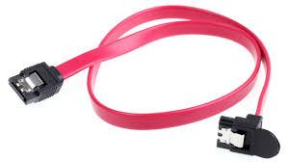
Pic: sata cable

1.5.3.3 PATA
PATA, short for Parallel ATA, is an IDE standard for connecting storage devices like hard drives and optical drives to the motherboard. PATA generally refers to the types of cables and connections that follow this standard. It's important to note that the term Parallel ATA used to simply be called ATA. ATA was renamed to Parallel ATA when the newer Serial ATA (SATA) standard came into being. PATA cables are flat cables with 40-pin connectors (in a 20x2 matrix) on either side of the cable. One end of the cable plugs into a port on the motherboard, usually labeled IDE, and the other into the back of a storage device like a hard drive. Some cables have an additional PATA connector midway through the cable for connecting yet another device like a PATA hard drive or an optical disk drive. ATA-4 drives, or UDMA-33 drives, can transfer data at a maximum rate of 33 MB/s. ATA-6 devices support up to 100 MB/s speeds and might be called PATA/100 drives. The maximum allowable length of a PATA cable is 18 inches (457 mm).
NOTE:
1.IDE , PATA and ATA are now used synonymously.
2.IDE refers to the first-generation PATA drives.

